
Blue Team Shooting Sports A.S.S.S. May 26th. 2026
COURSE DESIGNER: Ike Starnes

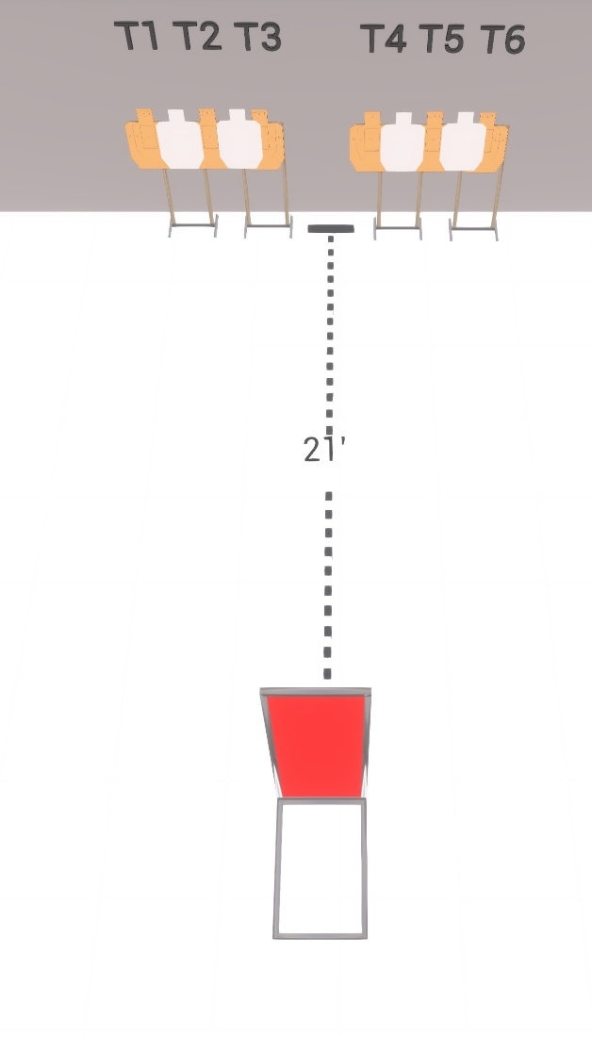

Written Stage Briefings:

Stage 1 – Unbreaking III - is a 12-round, 60 point, Virginia Count Course. There are 6 cardboard targets and some noshoots. The best 4 hits per cardboard target will be scored.
Handgun start position Hands touching upper marks. The handgun is loaded and holstered.
PCC start position Muzzle touching lower mark. PCC is loaded with stock touching belt.
On the audible start signal, engage T1-T3 from the left side of the barricade with only 2 rounds each, then make a mandatory reload and engage T4-T6 from the right side of the barricade with only 2 rounds each. Shooters may start with either array without penalty.

